Shopping List

The aim of this exercise is to use a spreadsheet to work out how much a grocery bill would cost and then to display how much is spent on each item in the form of a pie chart.

Having opened up the spreadsheet label the columns as follows:
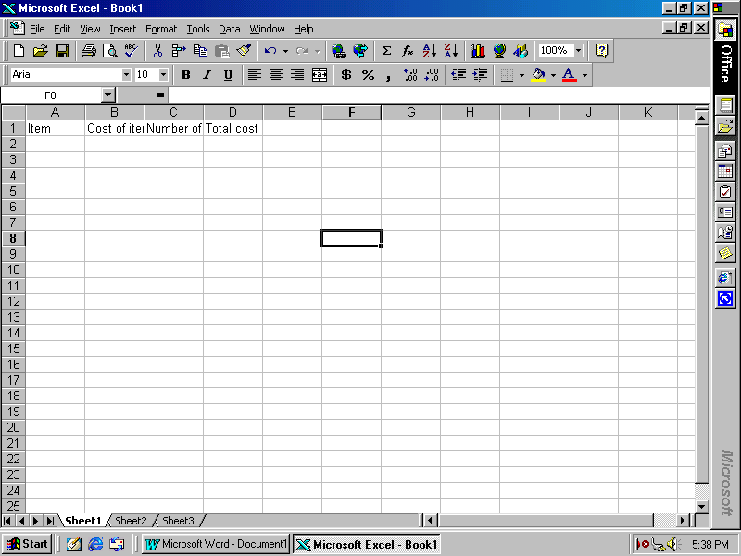
Item, Cost of item, Number of items, Total cost

You will probably find that your spreadsheet looks like this. Do not worry about the appearance at the moment.

Under the heading Item type in the following list: Apples, Pears, Bananas, Oranges, Lemons and Melons.
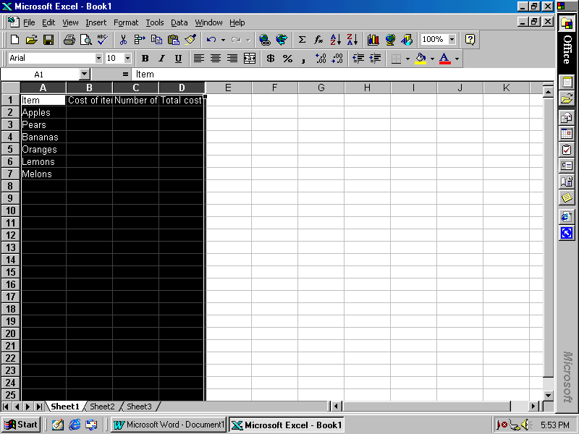
Now click on the letters A,B,C and D at the top of the columns so that the columns are highlighted.

Now change the font size to 16

Now we want to adjust the sizes of the cells so that the words fit neatly into the cells.

Leaving the columns highlighted select:
Format - Column - Autofit Selection
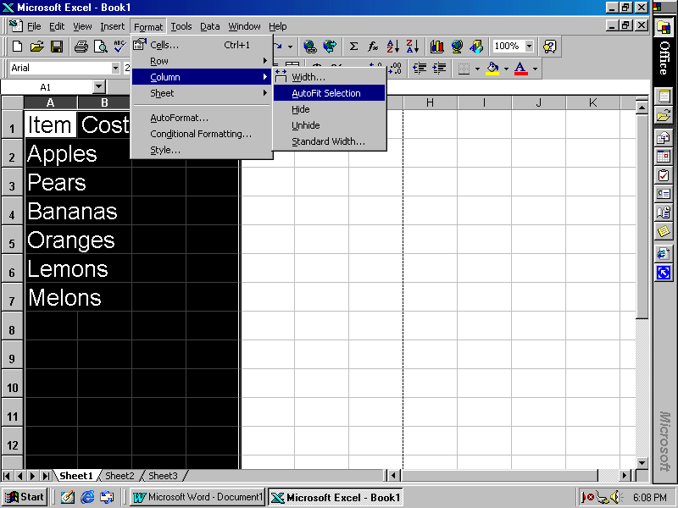

We want the spreadsheet to know that we are going to be dealing with money in columns B and D. So click on the B at the top and select:
Format - Cells - Currency - English (United Kingdom)

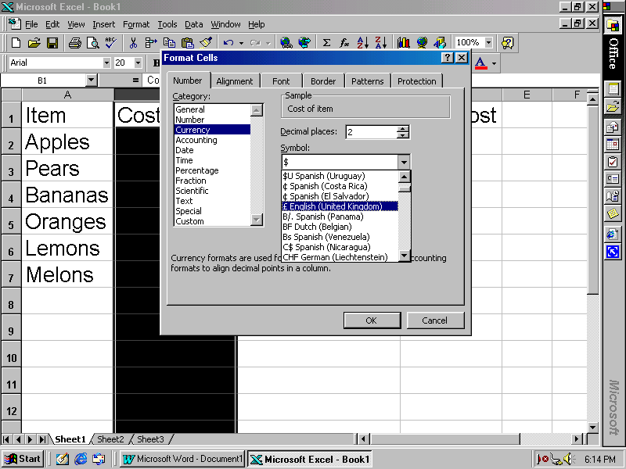
Do the same for column D. This means that the computer will put in the pound sign and record it to 2 decimal places.
Enter the information that Apples cost 13p, Pears cost 21p, Bananas costs 15p, Oranges cost 17p, Lemons cost 26p and Melons cost 52p.
[You will need to enter the data in pounds, so 13p = £0.13]

Also we require 7 apples, 4 pears, 8 bananas, 1 lemon and 2 melons.

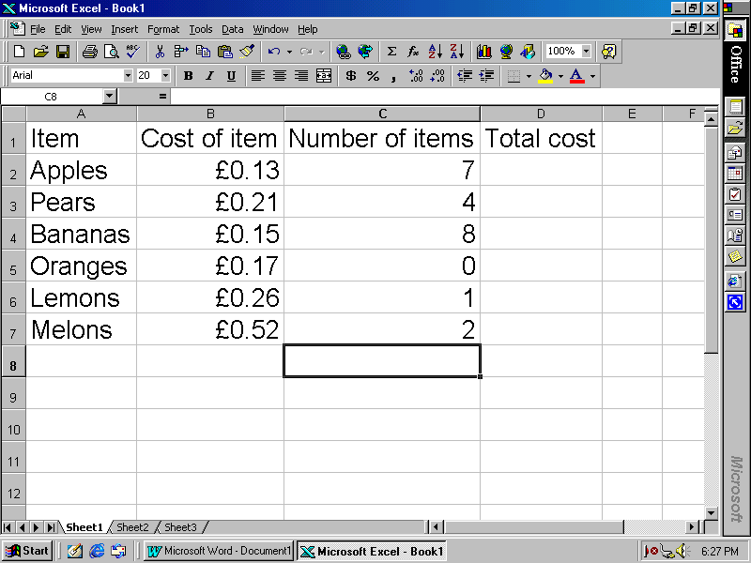
Highlight columns B, C and D and centre the information by clicking on this button.

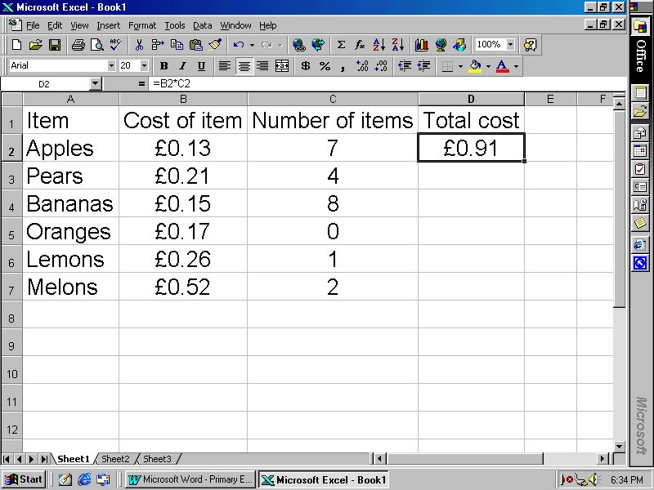
We now want to enter a formula to work out the cost of each item. Click on cell D2 Press = then click on cell B2 press * and then click on cell C2 so that this appears in the cell: =B2*C2 now press enter.
Click back on cell D2 so that it appears as above and then click on the small square in the bottom right hand corner of the cell and drag down.
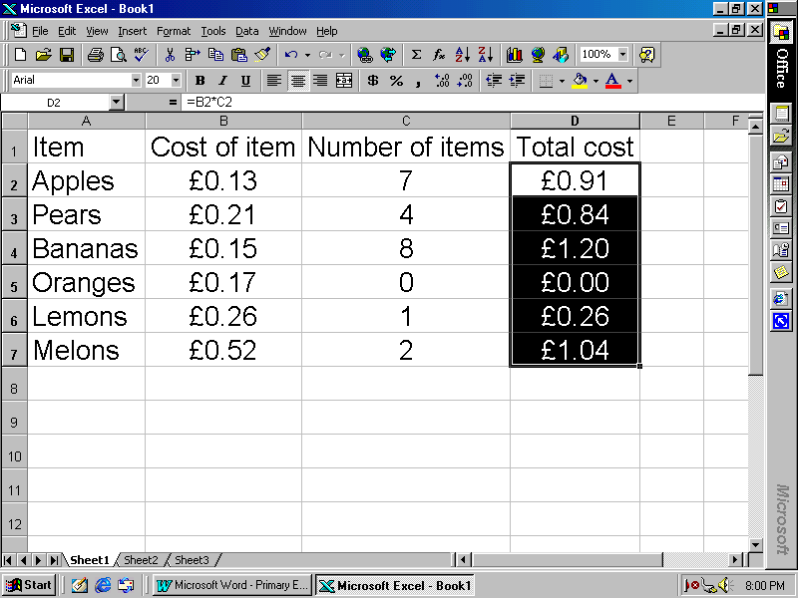

Finally we want to work out the total bill. Write the word Bill in cell C9. In cell D9 press = sum( then highlight the cells as above and press ) then enter.
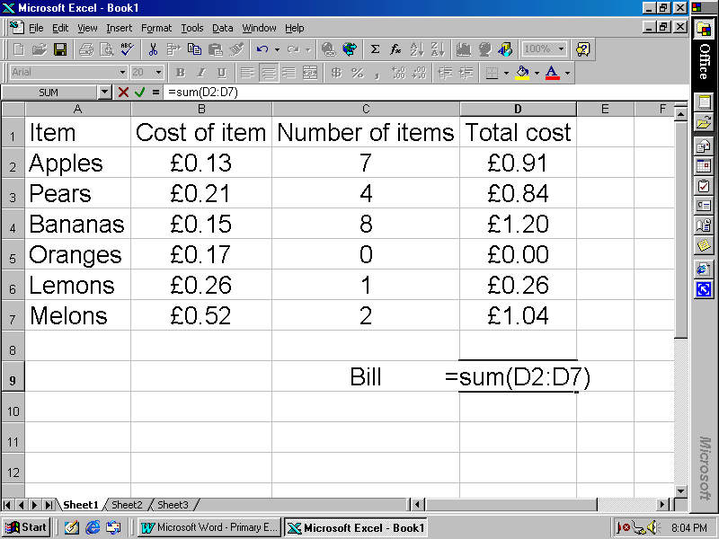
This should give a total of £4.25

Pose several questions such as what if I buy 2 apples instead, or 6 oranges, or the price of bananas goes up to 18p. All you have to do is change the entry in the Cost of item column or the Price of item column.

Now we shall draw a pie chart to represent the shopping bill they are left with.

Highlight the items on the left including the heading, whilst holding down the Ctrl button highlight the Total cost column.
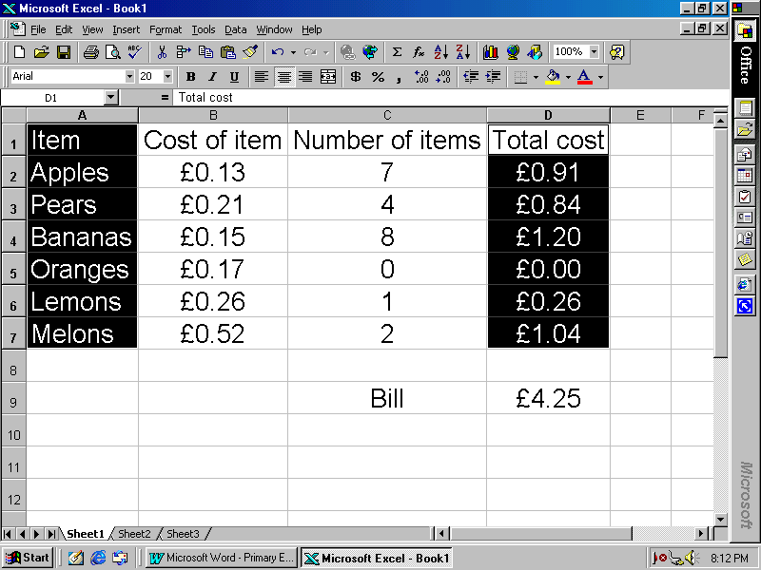

Now select the chart icon at the top of the screen and draw a pie chart as shown on an earlier instruction sheet.

It should be possible to place the pie chart below the table on the spreadsheet and alter it's size and position. I have also included a Header and a Footer (Press View then Header/Footer) and used the border button to draw a grid around the data.

[Note that if you change the data in the table that the chart changes automatically.]

